MTH 200 | Curve Sketching

Directions: Solve all problems on a separate sheet(s) of paper. Place your name on the pages you submit. You must show all of your work to receive full credit on problems. You must write complete sentences when asked to show/prove something or provide an explanation/justification. You are encouraged to work with others, consult sources, use calculators, etc. However, only submit solutions that you fully understand. Do not submit solutions which are copied from a friend or another source.

Challenge Questions

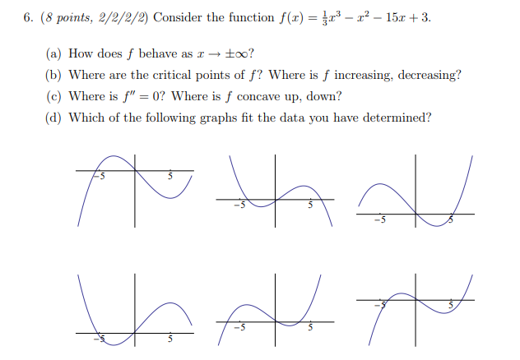

- Let be a differentiable function defined for all real numbers such that . Let be the square of the distance from the origin to .
- Show that if the tangent line to at is perpendicular to the line containing the origin and the point .

We see that .
We calculate that .

We note that the slope of the line containing the origin and the point is given by and so if the tangent line to at a is perpendicular to this line then is must be the case that
Using all of this we can see that

- If a continuous function on the real numbers has the property that and , then the function must have an absolute minimum. Use this fact and part (a) to show that there does exists at least on value a where the tangent line to at is perpendicular to the line contain the origin and the point .

From part (a) we know that . This must a differentiable function since we given that is differentiable. As such, must also be continuous.
Clearly then and , and so by the given fact must have an absolute minimum.

Clearly though if has a has an absolute minimum value and since is differentiable at all values, then by Fermat’s Theorem it must be the case that there exists a value , such that .

We know from part (a) that the tangent line to at is perpendicular to the line contain the origin and the point only if . Therefore, we can conclude that there exists a value of x where the tangent line to at is perpendicular to the line contain the origin and the point .

